**Olympic College ctcLink Implementation**

**Project Plan**

**DRAFT**



**Table of Contents**

**1.0 Purpose** 4

**2.0 Introduction/Background** 4

**3.0 Executive Summary of Project Charter** 4

**4.0 Scope** 5

**5.0 Work Breakdown Structure** 5

**WBS 1.1 Data Cleansing, Mapping and Interface to ctcLink** 6

**WBS 1.2 Inventory and Recommendations for Shadow systems** 6

**WBS 1.3 Business Process Analysis and Alignment to ctcLink** 6

**WBS 1.4 Business Process Improvement** 6

**WBS 1.5 Training** 6

**WBS 1.6 User Acceptance Testing and Configuration** 6

**6.0 Schedule** 7

**7.0 Project Staffing** 8

**8.0 Budget Management (Under Construction)** 9

**9.0 Project Management** 10

**9.1 Project Team Meetings** 10

**9.2 Risk Management** 10

**9.3 Metrics** 10

**9.4 Management of Project Data** 10

**10.0 Communications Management** 11

**11.0 Organizational Change Management** 12

**12.0 Project Closeout** 13

# **1.0 Purpose**

The purpose of this document is to provide a plan that dovetails with the State Board ctcLink implementation and provides the detail needed for a successful implementation at Olympic College.

# **2.0 Introduction/Background**

ctcLink is the implementation of a single, centralized system of online student and administrative functions that will give students, faculty and staff anytime, online access to a modern, efficient way of doing their college business. It includes a new set of integrated software tools for student administration, academics, student finance, college financials, HR/payroll and reporting. As the legacy software is replaced with modern technology, all 34 colleges will also redesign and align core business processes with streamlined and standardized best practices. ctcLink utilizes PeopleSoft software for Campus Solutions, Human Capital Management and Financial processes.

FirstLink colleges, Tacoma and Spokane have go live dates in November 2014 followed by three waves of implementation with a completion date of 2017. Olympic College is part of wave 2 with a go live date of May 2016.

# **3.0 Executive Summary of Project Charter**

The following provides key information from the project charter, which was approved by the Olympic College Cabinet. A full copy of the charter is available in the Project Management folder listed in section 9.4.

-Project start date January 31, 2014

-Key Objectives

Modify OC business practice to reflect best practices.

Adopt all of the self-service functionality provided by the new system.

Empower students to make choices about their education.

Eliminate as many shadow systems as possible and still remain in compliance with local, state and federal regulations.

-Key Assumptions

SBCTC CIS will provide consultation to support the conversion.

SBCTC CIS will provide training modules for the PeopleSoft (PS) system.

OC will need to hire part-time employees to backfill for the implementation team who will have a larger share of implementing the project.

Employee self-service in the new system will be maximized.

# **4.0 Scope**

**The following are considered within the scope of this project:**

-All work detailed in the following Work Breakdown structure

-All activities required by SBCTC for ctcLink implementation

**The following are considered out of scope:**

-Business Process Analysis and Improvements not related to the three pillars of PeopleSoft

-Improvements/Enhancements to shadow systems

# **5.0 Work Breakdown Structure**



## 

## **WBS 1.1 Data Cleansing, Mapping and Interface to ctcLink**

These tasks include cleansing legacy data to endure data is accurate prior to moving to ctcLink. Additionally 1.1 includes the design and development of a local Operational Data Store (ODS) for archiving and retrieving data older than 6 years.

## **WBS 1.2 Inventory and Recommendations for Shadow systems**

This includes the documentation of all Shadow Systems currently utilized at Olympic College, analysis of future need and recommendations to keep or eliminate the system.

## **WBS 1.3 Business Process Analysis and Alignment to ctcLink**

SBCTC provided an Excel spreadsheet that lists each of the approximately 3800 steps in the 242 Business Process Diagrams and the PeopleSoft role for performing each step. Using the spreadsheet, SMEs will:

-assign each step to the correct SME

-document who currently performs that step using legacy, their title and who they report to

-document degree of change from legacy to ctcLink

-document “as is” process and existing procedures

-review “to be” process using UPKs, PeopleBook and BPA sessions and discuss changes from “as is”

-document the improvement potential, question and actions for each step

-identify areas where policy needs to be reviewed and/or revised

## **WBS 1.4 Business Process Improvement**

Business process improvements will result directly from the implementation of ctcLink PeopleSoft. Additional improvements can be generated by analyzing and improving business processes that are outside, but closely related to, the PeopleSoft processes. For example, the PeopleSoft process for managing academic standing appears to have significant improvements that will reduce the amount of time and labor compared to performing that process in legacy. But, additional improvements may be developed by reviewing the policies that set values and drive academic standing.

Using the same spreadsheet as 1.3, SMEs will analyze the BPD steps that have improvement potential and develop and document improvements. Where appropriate, the step will be flagged to measure the “as is” process and the “to be” process after implementation. These measures will develop into Key Performance Indicators (KPI).

## **WBS 1.5 Training**

This includes the development of a detailed training plan and schedule that will identify who will attend which training sessions, the time and location.

## **WBS 1.6 User Acceptance Testing and Configuration**

This section includes the development of a User Acceptance Test plan that dovetails with the SB schedule and assigns individuals to perform testing. This section also includes the completion of system configuration.

# **6.0 Schedule**

The following is the initial version of the project schedule. An updated version of the schedule will be available in the Project Management folder listed in section 9.4.



# **7.0 Project Staffing**

The following table lists the members of the Olympic College ctcLink Project Team.



The following RACI table describes the responsibilities of Project Team Members.

 Legend: R=Responsible, A=Accountable, S=Support/Assist

# **8.0 Budget Management (Under Construction)**

The following provides a detailed budget for the project.



Actual amounts expended will be collected and reported monthly.

# **9.0 Project Management**

## **9.1 Project Team Meetings**

The Olympic College ctcLink Project Management Team will initially meet once a month and will increase the frequency of meetings as we get closer to go live date. The team agenda will include

Schedule review, budget planned and actual, major issues will be discussed and logged and risk matrix will be reviewed and updated.

## **9.2 Risk Management**

The team will document risks and evaluate movement and mitigation monthly. Risks will be shown in the following format:

Current version of Risk Matrix is available in the Project Management folder listed in 9.4.



## **9.3 Metrics**

The team will generate and disseminate the following monthly metrics:

-Schedule % complete for each level three WBS element

-Budget Planned/Actual spend

-Number, magnitude and status of Process Improvements

Monthly metrics will be distributed as shown in section 10.0 and will reside in the Project Management folder listed in 9.4.

## **9.4 Management of Project Data**

Project Data will reside at \\vmoffbcommon01\Shared Documents and Forms\ctcLink\Project Management Team Data and is available at the following link: \\vmoffbcommon01. Access to the data will be limited to the Project Team defined in section 7 and the folder will be maintained by the Project Manager

# **10.0 Communications Management**

The following table describes the planned communications for this project.



SBCTC Communication Plans are linked below.

[**Communication Strategy and Plan**](http://www.sbctc.ctc.edu/docs/collegeaccess/it/it/ctcLink_Communications_Strategy_and_Plan-final.docx)

[**Supplement to Communication Plan**](http://www.sbctc.ctc.edu/docs/collegeaccess/it/it/Ciber_Supplement_Communication_Plan-March2013.pdf)

# 

# **11.0 Organizational Change Management**

The implementation of ctcLink presents a sea change for much of the College, especially in the business processes represented by the legacy systems. Olympic College strategy for managing that change is to increase awareness and understanding of the new business processes in PeopleSoft through the communications listed in section 10 and by including as many employees as practical in the Business Process Analysis and Improvement Workshops.

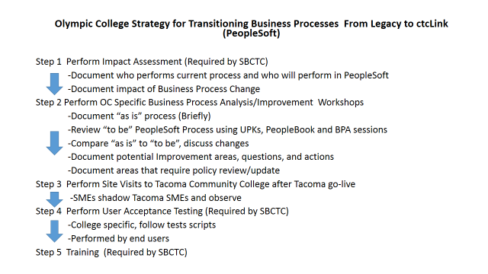

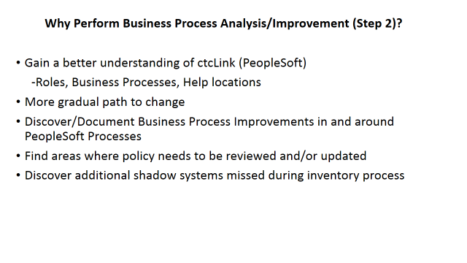

The following provide links to the SBCTC Organizational Change Management Plans.

[OCM Strategy and Plan](http://www.sbctc.ctc.edu/docs/collegeaccess/it/it/ctcLinkOCMPlan-Finalv13-15-13.pdf) [Supplement to OCM Strategy and Plan](http://www.sbctc.ctc.edu/docs/collegeaccess/it/it/SBCTC-2.1.4.2-FinalizedOrganizationalChangeManagementPlan-PMO-GBL-V2.docx)

# **12.0 Project Closeout**

Within the month following go live, the Project Team will complete a final monthly project report and perform, document and distribute a lessons learned session. Measurements of Key Indicators and Process Improvement efforts will continue after project closeout.

Appendix A: Project Management Plan Approval

_______________________________________________________ _______________________________

Mary Garguile Date

Vice President of Instruction

_______________________________________________________ _______________________________

Damon Bell Date

Vice President of Student Services & Achievement

_______________________________________________________ _______________________________

Bruce Riveland Date

Vice President for Administrative Services

_______________________________________________________ _______________________________

vacant Date

Vice President for Equity and Inclusion

_______________________________________________________ _______________________________

Joan Hanten Date

Vice President for for College Relations